First National conference on drug policies “From Law to public health”, Skopje, 30.9.2014
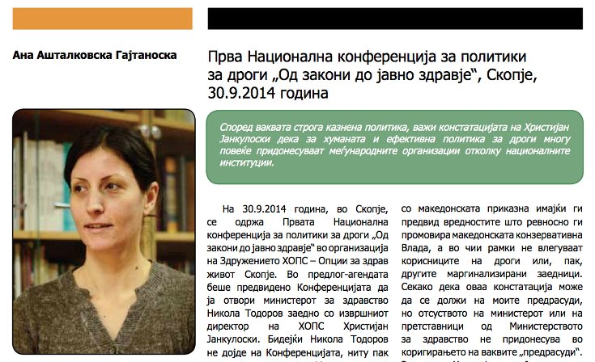On 30.9.2014 in Skopje, the First National conference on drug policies “From Law to Public Health” was held, organized by the Association HOPS – Healthy Options Project Skopje. In the draft agenda it was planned for the Conference to be opened by the Minister of Health Nikola Todorov together with the executive director of HOPS, Hristijan Jankuloski. Because neither Nikola Todorov, nor any other representative from Ministry came to the Conference, we were left to imagine what the positions and activities of one of the key institutions when it comes to drug policies could be. So it remained unclear what is happening with the National drug strategy, which was adopted in June 2014, and in which preparation participated members from the civic sector, inclusive members from HOPS, but none of them saw the final document that was already adopted. At the same time, it became unclear what is happening with the position of the national coordinator on drugs of the Republic of Macedonia, which has been empty and not functional for over a year now. On a more positive note, the conference was also attended by Jindřich Vobořil, a national anti-drug coordinator of the Czech Republic, who happens to be a member of a conservative political party, who remained on this function for 4 years, despite the change in political power in Czech Republic. This information alone is “exotic” for us, when compared to the Macedonian circumstances, having in mind the values very zealously promoted by the conservative Macedonian government, which do not include drug users, or any other marginalized communities. Of course, this conclusion can be the result of my prejudices, but the absence of the minister or any other ministry representatives does not contribute towards correcting these “prejudices”. That is why Hristijan Jankuloski, the executive director of HOPS, justifiably refused to excuse the representatives of the Ministry of health because the section titles “National drug policies, European and Macedonian experiences” remained limited to some official representatives of Europe. Macedonian experiences were presented from the perspective of civic organizations, mainly HOPS, starting off from the exceptionally informative presentation by Natasha Boshkova, a lawyer from HOPS. Contrary to the need for humanizing the drug policy in Macedonia, the need for drug decriminalization and social and health support (because in addition to being humane, they also offer economically effective strategies, based on Czech Republic’s experiences), Macedonia chooses suppression, penal policy and criminalization of drug use. This works towards strengthening the “prejudices” mentioned above, because of the current practice to interpret the Law in a more severe manner than prescribed, when it comes to drug users. In this context goes this illustrative example: in addition to the fact that possession and transport of drugs for personal use is not sanctioned by the Criminal Code, still, in the period from October 2012 to December 2013, 600 individuals were persecuted for a criminal offence as opposed to only nine who were persecuted for a minor offence, which follows a strange logic that there are more dealers than drug users in Macedonia. Ironically comforting, in a way that “there always are situations worse than ours” was the presentation of Ivan Varentsov from the Andrey Rylkov Foundation from Russia. In line with this strong punitive policy goes the conclusion of Hristijan Jankuloski that international organizations contribute more towards the humane and effective drug policy than national institutions. According to Vlatko Dekov, this policy of isolation, discrimination, punishment, which means re-education, contributes to the additional stigmatization of drug users.
In the second session of the conference, titles “Human rights of drug users”, we heard Jaka Bitenc from the Slovenia Cannabis Social Club - SCSC, Zharko Trajanoski from the Coalition “Sexual and Health Rights of Marginalized Communities” and Vanja Dimitrievski, program assistant at HOPS. Certain presentations, such as that of Natasha Boshkova and Zharko Trajanovski, caused reactions by some representatives from public institutions working with drugs users, judiciary and the police. In these debates, the “opposing party” were the representatives of the civil sector, who contact with drug users on daily basis, and were able to talk about their problems, and plus – representatives from public institutions who are also encountering drug users, but with the difference that this group, subject of discussion, was replaced by drug dealers among the latter. Due to this, the dilemma remains unresolved, whether this identification of drug users with drug dealers is the consequence of misunderstanding or of stereotypical equalization of all those who have any connection with drugs and their labeling as criminals. Thus, the impression is gained that there is a serious lack of capacity to treat marginalized communities appropriately by public institutions and this is most often the result of the layman approach towards drug users. Again, this layman approach is probably due to the serious lack of capacity to understand and tolerate differences, i.e. their inability to assess own stereotypes possibly through education, which has been shown as typical for certain professionals from public institutions of this Conference. This assumption became further strengthened by the terminology used in discussions where the term drug users was almost always absent from the talks of public institutions. Their analyses concentrated mainly on drug dealers (according to their statements, these people belong to prison and society should protect itself against instigators) or, when they had to be named somehow, without using a popular offensive term, because of political correctness, finding an appropriate term was harder than we assumed: “your... how should I call them... the ones you did the interview with” ... “certain statements of these...”, ... “some of those...”. Although it might sound romantic to talk about a capacity to understand and tolerate differences or to reassess the stereotypes of a professional who deals with an “exact” matter such as the law, it is still exactly the judges who make decide about drug users, and according to the data stated above, even 600 vs. 9 were quite severely punished. Thus, they might need to bring some “poetics” in their own practice. The matter in this “exact” science is surely subject to different interpretations. Finally, prejudices surely arise, despite all the exact methods, from subjective aspects of things, i.e. from the person put in the position of a judge. Here I think about his character, his personal attitudes, emotions, experiences, prior knowledge, education or information about the specific issue, personal prejudices... (this is an almost complete list), i.e. from all that creates their reference system. No matter how banal these elements of the subjective reference system may sound, they unavoidably mix with and complicate the strict exactness of science (and this is the case also with physicists, mathematicians and other natural science professionals, as most exact among the exact sciences), and especially when people are put in the position to judge for other people. Defending one’s own profession (judiciary and police) by stating “...there haven’t been any such situations in Skopje, nor will there be” in this context seems naive.
In the last section titled “Drug regulating models. What is the most appropriate model in Macedonia?” presenters were Vlatko Dekov, program manager in HOPS, Nikola Tupanchevski from the Faculty of Law, and Slavica Gajdazis-Knezhevikj, from the Institute on marriage and family. Conclusions were towards the necessary humanization of the drug policy in Macedonia, but there still seems to be lacking the appropriate mood and capacity of competent institutions to implement this humane practice.
* This text has also been submitted and shall be published in the magazine EtnoAntropoZoom no. 11 published by the Ethnology and Anthropology Institute, Faculty of Natural Sciences, UKM. (http://iea.pmf.ukim.edu.mk/MKD/EtnoAntropoZum.html)
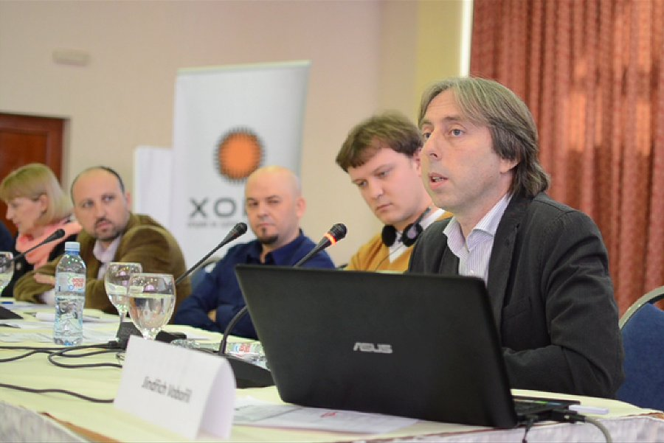First National Conference on drug policies “From Laws to Public Health”
On 30.9.2014 in Skopje, the First National conference on drug policies “From Laws to Public Health” was held, organized by the Association HOPS – Healthy Options Project Skopje. At the conference, around 50 participants from the country and abroad, among whom the national coordinator on drugs of the Czech Republic, Jindřich Vobořil, discussed whether repressive drug policies yield results, whether decriminalization of drugs is a more effective policy and what are the Macedonian, Czech, Russian and Slovene experiences. A key conclusion was that repressive policies are inhumane, do not decrease drug use and give no results. The following conclusions were brought at the conference:
Conclusions from the first National Conference on drug policies “From Laws to Public Health”
1. The repressive policies for resolving the question of drug use yield no results. An example is Russia, which leads such a policy, and faces a significant amount of issues in regard to high incidence and prevalence of HIV, especially among drug injecting individuals, a small number of people in treatment for drug dependence, serious human rights violations, big financial costs, mostly in the health, social and legal system etc.
2. The National strategy on drugs of the Republic of Macedonia and the action plans must be adopted with appropriate budgets for their realization. Prior to their adoption, documents should go through a wide public debate.
3. There is a incongruence in the description of the characteristics of the criminal offences 215 and 216 of the Criminal Code and the cases in which they are applied by judges in stating verdicts related to these articles.
4. A legal differentiation is needed regarding which drug use will be considered a misdemeanor, and which will be within the range of the criminal offence enabling the use of drugs.
5. Articles 215, 216 and 217 from Chapter 21 of the Criminal Code should be further specified toward establishing what a small amount of drugs means, and making a serious distinction between misdemeanor and criminal offences. A specific provision should clearly differentiate between people possessing and producing drugs for sales and people who possess and produce for personal use. The description of these articles should be simplified and separate in several paragraphs.
6. To change the wording in laws containing articles related to drug regulations, in line with internationally accepted terminology.
7. Alternative penalties for drug related offences should be used to a greater extent instead of prison sentences.
8. To introduce a system for analysis and evaluation of the legal regulation and its application.
9. In some towns, there is improvement in police practice and the relation of the Police towards drug users, but still, on a national level, this is unsatisfactory and a change is needed.
10. The national drug policy should be based on pragmatism and respect of human rights. In that direction a consensus is needed among all stakeholders because issues related to drug use are, above all, issues of public health and social policy.
11. All organizations and institutions from the field, should actively work against the stigma and discrimination against people using drugs. These changes should lead us towards pragmatic policies that will protect the public health.
V.D.
Ana Ashtalkovska Gajtanoska
Ana Ashtalkovska Gajtanoska is a docent at the Institute of ethnology and anthropology at the Faculty of Mathematics, UCM, Skopje. She has lately been concerned with topics related to methodological aspects of humanistic research.

